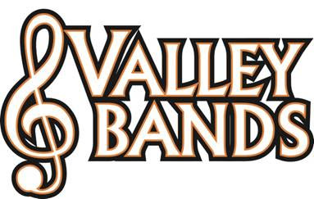
“Rent a Youth” _______________ (Marchmaster Name)
Valley Marchmasters will be performing in the “Remembering the Heroes Performance at USS Bowfin” in Honolulu, Hawaii on Sunday March 15th, 2015. USS Bowfin (SS-287) is a fleet attack submarine that fought in the Pacific during WWII, and helped to make famous the term, “Silent Service.” Bowfin was launched on 7 December 1942, exactly one year to the day after the attack on Pearl Harbor. She was nicknamed the Pearl Harbor Avenger, so it is fitting that she is permanently home ported at Pearl Harbor, Hawaii.

Valley Marchmasters students are raising money to fund a trip next spring break to play on the USS Bowfin. Valley Marchmasters “YOUTHS FOR RENT” are available to do tasks such as:
Mowing grass Raking leaves Shoveling snow Washing windows
Spring cleaning Garage clean-up Walking dogs Weeding the garden
Baby sitting Yard clean-up House cleaning
Or other tasks you need completed!

The Valley Marchmasters would appreciate any work you may have that they can perform to help support their quest to perform on the USS Bowfin in support of our military personnel. If you have a task that you need help completing please send a message to e-mail address listed below that includes the following:
- Description of Task
- Estimate of Time Needed to Complete the Task
- Valley Marchmasters That You Would Like To Perform The Task (Optional)
- How did you hear about this (do you personally know any Marchmasters?)

Thanks so very much for your support. Suggested donation of $25/hour minimum for services.
rentayouth@valleybands.org
USS Bowfin USS Bowfin Flag with patches for ships sank
